Central African Republic Infant Mortality

Lizette Romano

HSC 400: Descriptive Epidemiological Paper

Infant mortality in the Central African Republic, 2013-2017
According to the World Bank (2018a), in 2013 the Central African Republic [CAR] surpassed Sierra Leone as the country with the highest infant mortality rate in the world. Since then, the CAR has continued to have the highest infant mortality rate with a rate of 87.6 deaths for every 1,000 live births as of 2017 (World Bank, 2018a). Infant mortality is the number of infants who die under the age of one for every 1,000 babies born alive.
Infant mortality is an important topic to address because according to the World Health Organization [WHO] (2018), 75% of deaths in the “under-five” category happen before a child can reach their first birthday. With this in mind it is important to note that Sub-Saharan Africa, the region that the CAR is part of, accounts for 50% of under-five deaths in the world (United Nations International Children’s Emergency Fund [UNICEF], 2018a).
Agent and Condition
Infant mortality accounts for deaths anytime from birth until the first year of life. In the CAR, some determinants for infant mortality include low socioeconomic status (SES), exposure to an infectious disease, healthcare access, cultural norms, and gender. Gender will be discussed in the host factors of infant mortality. Exposure to an infectious disease is further explained in the environmental factors section. Low SES, healthcare access, and cultural norms will be discussed further in the SES section. Although exposure to an infectious disease can be a determinant for infant mortality, infant mortality is not transmitted by an infectious agent because an infant’s death would not be a condition spread to other infants.
Being born preterm, without access to health care, exposed to an infectious disease, or incurring other factors mentioned previously are some of the characteristics of infant mortality. A child that is born preterm faces lower survival rates if there is a lack of access to proper health care because of complications due to being preterm and the cost of treatments (United States Department of Health and Human Services [USDHHS], 2018).
Mechanisms to control
In surrounding Sub-Saharan African regions, infant mortality has been controlled with increased healthcare access and by incorporating comprehensive maternal care to women who are pregnant (UNICEF, 2018b); other methods include access to electricity, clean water, and soap. Increased healthcare access allows women to have access to doctors, nurses, and midwives which are all shown to affect infant mortality rates. In the CAR, there are about 3 of the previously mentioned healthcare providers for every 10,000 people (UNICEF, 2018b). This puts CAR as one of the regions in the world with the lowest available health care staff for its people. Healthcare providers are able to provide services, resources, and knowledge to help mothers maintain a healthy pregnancy or care for a preterm child. Both these factors affect infant mortality.
According to O’Hare, Makuta, Chiwaula, & Bar-Zeev (2013), income and the gross domestic product (GDP) of a region are associated with lower rates of infant mortality. The GDP helps measure the income of a region whereas individual income is also important to address infant mortality rates. Some ways that the GDP of a country could be controlled are by providing aid to the country and investing in programs to help the region’s economy advance in the long run. Individual income may be consequently controlled as the GDP increases since better economies result in more jobs.
The relationship between female literacy rates and infant mortality rates is shown in Appendix A (Susuman, Chialepeh, Bado, & Lailulo, 2016); there is an inverse relationship between these two since lower female literacy rates were associated with higher infant mortality rates. One way to control for high infant mortality would be to increase female literacy in the region. This allows mothers to be educated about keeping themselves and their child healthy during pregnancy, after, and about any complications their child may have that decreases their chance of survival.
Host Factors
Sex and gender are the biggest factors in infants for infant mortality in the CAR. According to Smith-greenaway & Trinitapoli (2014), in many regions of Sub-Saharan Africa boys are preferred over girls. This preference could affect the quality of treatment received before or after birth for girls if the parent does not want a girl. If girls are receiving poorer treatment or are experiencing poorer lives after birth, their survival rate decreases (Smith-greenaway & Trinitapoli, 2014). Although sex and gender are not the same, for the CAR, the assigned gender would be the gender correspondent to the child’s sex at birth.
SES
Income, occupation, education, family structure, and cultural background all play roles in the rates of infant mortality in the Sub-Saharan African region, and more specifically the CAR subregion. According to Appendix B, for places with the highest infant mortality rates a substantial amount of GDP investment is required to help subdue economic influences on infant mortality (O’Hare et al., 2013). The amount of investment needed is alarming and may be a strong factor in the infant mortality rate in the CAR. In 2013, there was a sharp economic drop for the CAR that stayed low for about two years as can be seen in Appendix C (World Bank, 2018b); there has been growth after 2015 but a drastic decline in the economy often affects people much longer.
As discussed previously, female literacy plays an important role in decreasing rates of infant mortality. Low female literacy rates have been associated with higher infant mortality rates (Susuman et al., 2016). Family structure and cultural beliefs might be intertwined with low female literacy. In a culture where women are seen as less than men, they are also less likely to receive education and know about their reproductive health (Smith-greenaway & Trinitapoli, 2014). Cultural norms of acceptable family structures also play a role in infant mortality. Smith-greenaway & Trinitapoli (2014) found that polygamous relationships had higher rates of infant mortality because of gender inequality and a lack of access to resources. The exception to having higher rates was in places that polygamy was less common since these places often had more equal gender roles and were less likely to view the women as property (Smith-greenaway & Trinitapoli, 2014); being seen as property increased the likelihood of women working during their pregnancy.
Environmental Factors
Environmental factors that increase the likelihood of infant mortality rates being high include exposure to an infectious disease and geographic location. Rural areas where women are more likely to spend their times working out on farms to make income are more likely to experience higher infant mortality rates (Smith-greenaway & Trinitapoli, 2014); this could also be due to having less healthcare services available nearby or not knowing they are pregnant until later in the pregnancy. Not accessing services early on in the pregnancy can increase the probability of complications after birth such as having to care for a preterm baby. An exposure to an infectious disease such as sepsis, meningitis, or pneumonia could cause serious complications in an infant and when left untreated can lead to the death of the infant (UNICEF, 2018b).
Temporal variations
Infant mortality rates in the CAR from 2013-2017 can be seen as an epidemic because more cases have occurred than what is thought to be the normal amount of cases. Infant mortality rates should be addressed for the CAR because it surpasses its neighboring regions. Appendix D shows a downward linear progression of Sub-Saharan infant mortality rates from 2013-2017 with current rates at 51.5 (World Bank, 2018c). In comparison, Appendix E portrays a similar downward trend in the CAR but a slower decline from 2016-2017, with current rates at 87.6 (World Bank, 2018d). When comparing both graphs, one can see the disparity in infant mortality rates between the main Sub-Saharan African region and the CAR subregion.
Description of current hypothesis
The current hypotheses for the high rates of infant mortality in the CAR include lack of access to healthcare providers and services, low SES families, polygamous relationships, and low female literacy rates. These hypotheses are formed around structural systems of the CAR such as political and cultural issues with gender equality, healthcare access for lower income populations, and the educational system for women in the CAR region. Low SES families may share the characteristic of lacking access to healthcare and therefore poorer nutrition or having a low female literacy rate because education may be too expensive. For polygamous relationships, the hypothesis is that there may be gender inequality or unequal resources provided for the women involved.
Gaps in knowledge/further research
Gaps in knowledge exist regarding whether female infants truly receive poorer care and if unequal care towards them has also been exhibited by healthcare providers. Gaps also exist regarding cultural norms, economic impact, single mothers, and women’s perspectives of the issue. Additional epidemiological variables that may be involved are the distribution of populations in rural and urban areas, ethnicity for groups in the CAR region with higher infant mortality rates, nativity, and migration. Data is currently unavailable for these variables in the specific CAR region.
Further research should explore biases of healthcare providers in treating different genders and families with low SES. Further research should also explore specific cultural norms to the CAR region, the economic impact of infant mortality for the people of the region, differences in single moms, and conduct qualitative studies about why rates of infant mortality are so high. Further research should also explore the CAR rural versus urban distributions of the population, nativity and ethnicity status, and migration activity in the region.
.

References
O’Hare, B., Makuta, I., Chiwaula, L., & Bar-Zeev, N. (2013). Income and child mortality in
developing countries: a systematic review and meta-analysis. Journal of the Royal
Society of Medicine, 106(10), 408–414. https://doi.org/10.1177/0141076813489680
Smith-greenaway, E., & Trinitapoli, J. (2014). Polygynous Contexts, Family Structure, and
Infant Mortality in Sub-Saharan Africa. Demography, 51(2), 341-66. doi:10.1007/s13524-013-0262-9
United Nations International Children’s Emergency Funds. (2018a). Under-five mortality.
Retrieved from
https://data.unicef.org/topic/child-survival/under-five-mortality/
United Nations International Children’s Emergency Funds. (2018b). Every child alive report.
Retrieved from
https://weshare.unicef.org/CS.aspx?VP3=SearchResult&ALID=2AMZIF2P99KK&VBI
D=2AMZVNC1SZ74&POPUPPN=1&POPUPIID=2AMZIF2P9NLU#/SearchResult&A
LID=2AMZIF2P99KK&VBID=2AMZVNC1SZ74
United States Department of Health and Human Services, Centers for Disease
Control and Prevention. (2018). Preterm birth. Retrieved from
https://www.cdc.gov/reproductivehealth/maternalinfanthealth/pretermbirth.htm
World Bank. (2018a). Mortality rate, infant (per 1,000 live births). Retrieved from
https://data.worldbank.org/indicator/SP.DYN.IMRT.IN?contextual=max&end=2017&loc
ations=CF&start=2013&view=chart
World Bank. (2018b). Gross national income for Central African Republic
[MKTGNICFA646NWDB]. Retrieved from
https://fred.stlouisfed.org/series/MKTGNICFA646NWDB
World Bank. (2018c). Infant mortality rate for developing countries in Sub-Saharan Africa
[SPDYNIMRTINSSA]. Retrieved from
https://fred.stlouisfed.org/series/SPDYNIMRTINSSA
World Bank. (2018d). Infant mortality rate for the Central African Republic
[SPDYNIMRTINCAF]. Retrieved from
https://fred.stlouisfed.org/series/SPDYNIMRTINCAF
World Health Organization. (2018). Infant mortality. Retrieved from
http://www.who.int/gho/child_health/mortality/neonatal_infant_text/en/

Appendix A
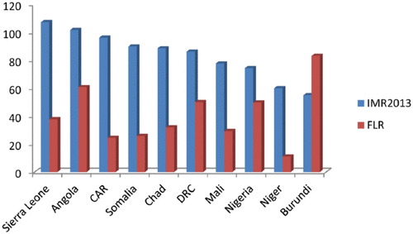
Source:
Susuman, A., Chialepeh, W., Bado, A., & Lailulo, Y. (2016). High infant mortality rate, high
total fertility rate and very low female literacy in selected African countries.
Scandinavian Journal of Public Health, 44(1), 2-5.
https://doi-org.csulb.idm.oclc.org/10.1177%2F1403494815604765

Appendix B
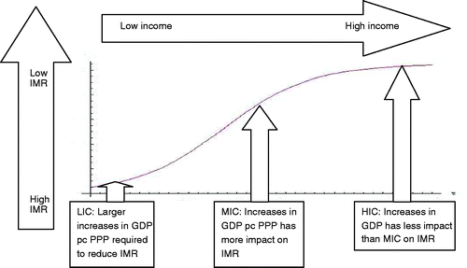
Source:
O’Hare, B., Makuta, I., Chiwaula, L., & Bar-Zeev, N. (2013). Income and child mortality in
developing countries: a systematic review and meta-analysis. Journal of the Royal Society of Medicine, 106(10), 408–414. https://doi.org/10.1177/0141076813489680

Appendix C

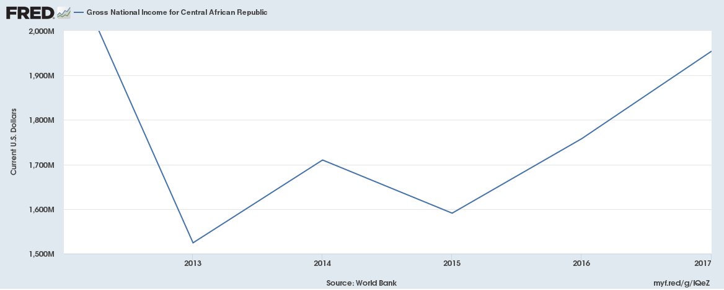
Source:
World Bank. (2018b). Gross National Income for Central African Republic
[MKTGNICFA646NWDB]. Retrieved from
https://fred.stlouisfed.org/series/MKTGNICFA646NWDB

Appendix D
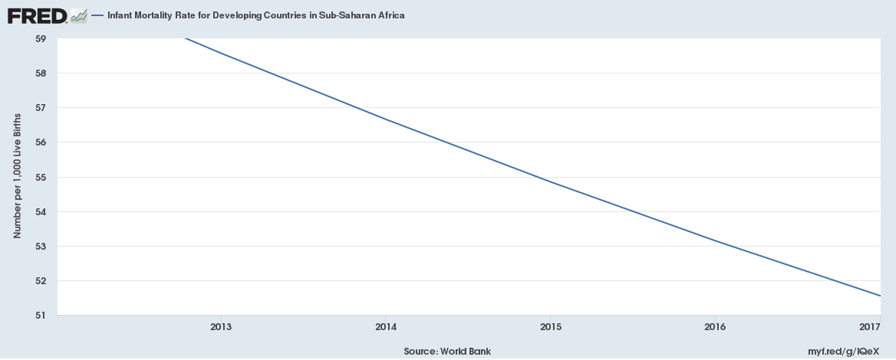
Source:
World Bank. (2018c). Infant mortality rate for developing countries in Sub-Saharan Africa
[SPDYNIMRTINSSA]. Retrieved from
https://fred.stlouisfed.org/series/SPDYNIMRTINSSA

Appendix E
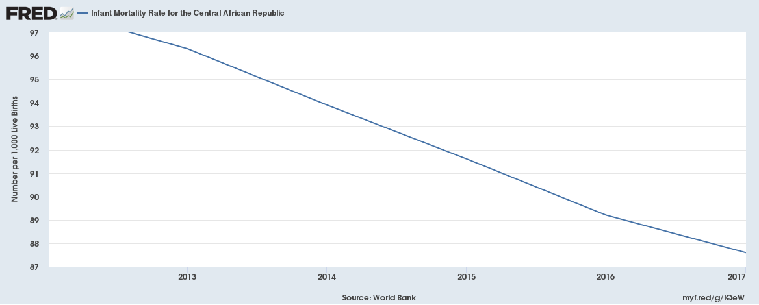
Source:
World Bank. (2018d). Infant mortality rate for the Central African Republic
[SPDYNIMRTINCAF]. Retrieved from
https://fred.stlouisfed.org/series/SPDYNIMRTINCAF

