Association Between Active Transportation Use and PM 2.5 Concentrations in Los Angeles County: Concerns on Equitable Distribution of Health Benefits

University of California, Los Angeles
Fielding School of Public Health

Environmental Health Sciences C200C

Faculty Advisor: Dr. Yifang Zhu
Ph.D. Student Advisor: Jonathan Liu

Aaron Barall, Cindy Chau, Kaylee Karsh, Alex Nguyen, Lizette Romano, To-Wei Ting, Gary Yen

Abstract
Active transportation (biking and walking) is beneficial to both human health and the environment by reducing the use of motorized forms of transit and PM2.5 emissions. However, these benefits are not equally distributed when considering economic and built environment dimensions. This study aims to use secondary data to establish a relationship between PM2.5 concentrations and active transport use in Los Angeles County. We hypothesize that census tracts with higher rates of active transport use are exposed to higher average concentrations of PM2.5. Using multivariate linear regression analysis, we developed two models associating estimated miles of total active transportation per capita and PM2.5 means: one controlling for various demographic factors and the other adjusting for neighborhood type as a categorical variable. We found a significant association between PM2.5 concentrations and census tracts with higher rates of active transport use when regressing on income and population density in our second model. We did not find significant associations when regressing on the percentage of non-white residents and percentage of renters. Further research on this topic would be valuable to help improve the equitable distribution of health benefits associated with increased active transportation use and to inform public health policy.
Introduction
Los Angeles County has developed long-term regional plans that prioritize economic development and community revitalization while balancing environmental protection. As LA County faces the consequences of suburban sprawl and traffic congestion, policymakers and urban planners increasingly realize that urban density can help mitigate these issues while still achieving local economic and environmental goals. Higher density promotes amenity-rich urban centers with destinations that are within close proximity. As a result, residents are more likely to engage in active transportation and reduce reliance on cars, which can help reduce traffic congestion and air pollutant emissions. As limited research has been done comparing exposures under walking and biking modes, the effects of active transportation behavior on potential exposure to traffic-related air pollution remain uncertain. Even with the limited research, it is inevitable that air pollutants pass through urban microenvironments. Therefore, we present our research and results on the relationship between average PM2.5 concentration and active transportation use across Los Angeles County census tracts.
Methods
In this study, active transportation was defined as walking and biking. Active transportation data for the Greater Los Angeles region was sourced from the UC Davis Dataset of Estimated Miles of Walking and Biking by Census Tract for California (National Center for Sustainable Transportation, 2014). From the dataset, we used the 2010-2012 CHTS, which surveyed nearly 105,000 residents for individual walking and biking distances. Residents were categorized by their age, gender, and home neighborhood type. These categories were matched with census data so that the sample could be expanded to represent population totals of Estimated Total Miles Walked and Estimated Total Miles Biked (Salon and Handy, 2014). The researchers further characterized each census tract by a neighborhood type: Suburb (nh_type 1), Urban (nh_type 2), Rural (nh_type 3) and Central City (nh_type 4). Neighborhood Types were determined by a K-means cluster analysis based on ten variables descriptive of neighborhoods, including population density, road density, job access, and new versus old housing (Salon and Handy, 2014).
For this study, we summed the Estimated Total Miles Walked and Estimated Total Miles Biked data for each census tract to determine the Estimated Total Miles of Active Transportation per census tract. Then each value was divided by the appropriate census tract population to calculate Estimated Total Miles of Active Transportation Per Capita. Census tracts that were missing data were excluded in the analysis. Neighborhood Type was considered a control variable for one of the regression models.
PM2.5 data
PM2.5 air quality data were sourced from 46 different locations in the Greater Los Angeles region according to Oroumiyeh et al. (2022). This publication details the methodology for site selection, which included a Multi-Criteria Decision Analysis and expert understanding of local geographies and PurpleAir densities, and sampling methods. Accordingly, samples were collected using Harvard cascade impactors and personal environmental monitors and then underwent chemical analysis. PM2.5 concentrations were then estimated through assays utilizing metals hypothesized to be tracers. The PM2.5 data from these filter samplers were combined with hourly-averaged and temporally aligned PurpleAir data. Cokriging with external drift was then applied to generate improved PM2.5 means.
The regional air quality data was provided by UCLA researchers in a spatial raster format. The data covered most of central Los Angeles County and western San Bernardino County, with some data available for 2,290 census tracts. The raster had an approximate resolution of 30m. The mean PM2.5 was calculated for each census tract using the Zonal Statistics Tool in ArcGIS Pro 10.9 on the raster surface (see Figure S1 and S2).
Demographics Data
Demographics and housing tenure data were sourced from the 2010 Decennial Census (US Census Bureau, 2011). Median income data was retrieved from the 2010 1-year American Communities Survey. Due to the U.S Census Bureau's categorization of Hispanic/Latino as an ethnicity, Hispanic/Latino individuals may be classified as one or more races (see Table S1). To account for this, the data was recorded to classify Hispanic/Latino individuals of any race as racially Hispanic/Latino. The percentage of each racial group was calculated for all census tracts and aggregated to create a simplified metric: percent non-white. Following a similar method, the percent of renter households was also calculated for each census tract.
Statistical Analysis
We approached our analysis assuming a linear relationship between independent and dependent variables. We performed a multivariate linear regression analysis for Estimated Miles of Total Active Transportation Per Capita and PM2.5 Means, while controlling for population density, income, percentage renter, percentage nonwhite population (Model 1). We repeated this regression while adjusting for “neighborhood type” as a categorical variable (Model 2). Based on the high degree of spatial interrelation in the air quality data due to the cokriged interpolation, we determined that it was appropriate to account for spatial autocorrelation in the regression model. We utilized a spatial lag model to adjust for spatial dependency in the PM2.5 data. We used the maximum likelihood to estimate the weights for the spatial lag model. Additionally, we utilized K-means clustering, a popular unsupervised machine learning algorithm, to cluster the census tracts based on race, population density, land area, PM2.5 means, income, active transportation per capita, and percentage nonwhite of each tract. We used a K value of 4 to best relate our clusters to the neighborhood type clusters already present in the data. R version 4.1.2 (2021) was used to carry out the statistical analysis. RStudio and ArcGIS Pro 10.9 were used to visualize results.
Results
We found that as the active transport miles increases, the average PM2.5 also increases. Fig. 3 shows that neighborhood type 3 (rural) had the least active transport miles (<0.25 miles per day) and low average PM2.5 concentrations while neighborhood Type 4 (central city) had the highest miles of active transport and the highest average PM2.5 concentrations. The Pearson correlation coefficient of 0.519 suggests a moderate association.
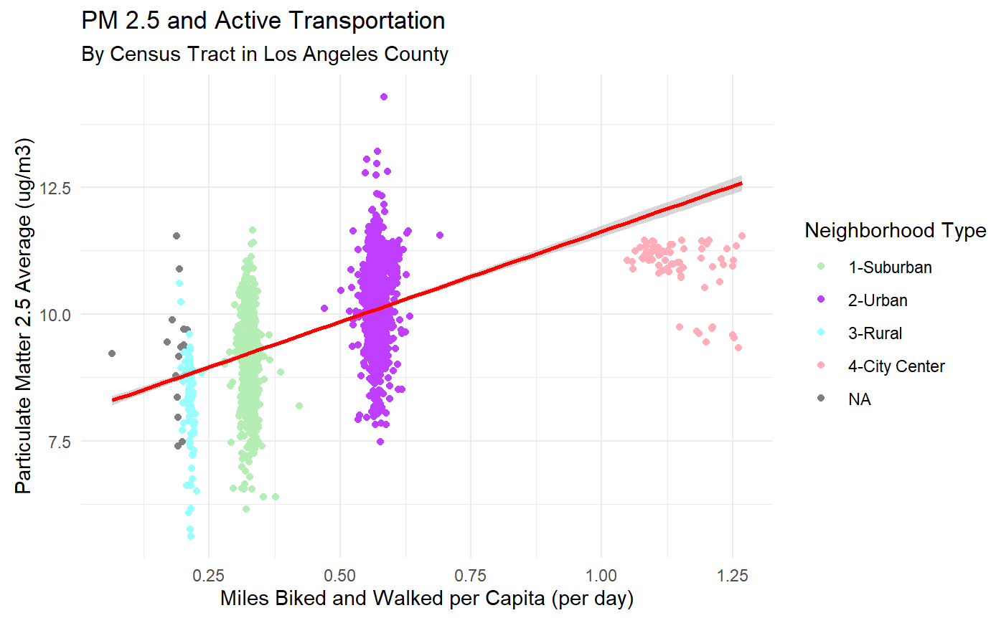
Figure 3. The relationship between average PM2.5 and miles biked and walked per capita (per day) in Los Angeles. (Pearson Correlation: 0.519)

 | Model 1 |  | Model 2
 | Estimate | P-Value | Estimate | P-Value
Miles Biked and Walked Per Capita | 1.41E-01 | 0.000626* | -4.71E-01 | 0.1274
Population Density | -1.92E-06 | 0.004273* | -1.53E-06 | 0.03192*
Median Household Income | -3.00E-07 | 0.349716 | -3.67E-07 | 0.25279
Renter % | 4.92E-02 | 0.15762 | 1.96E-02 | 0.59627
Nonwhite % | 3.28E-02 | 0.227528 | 1.79E-02 | 0.51295
Neighborhood Type 2 | - | - | 1.86E-01 | 0.0151*
Neighborhood Type 3 | - | - | -1.49E-01 | 0.01027*
Neighborhood Type 4 | - | - | 4.67E-01 | 0.06825
Table 1. Spatial Regression Models
In Model 1, there was a statistically significant positive correlation between miles biked and walked per capita and PM2.5 (Table 1). Other positive correlations for PM2.5 concentration included renter percentage and nonwhite percentages. Median household income was negatively correlated with PM2.5 concentration. Lastly, we found a significant negative correlation between PM2.5 concentration and population density. When accounting for neighborhood type in Model 2, the miles walked and biked per capita was not significant (p>0.1) and instead negatively correlated. Similar to Model 1, renter percentage and nonwhite percentage continued to be positively correlated with average PM2.5 concentration. Median household income was again negatively correlated with PM2.5 concentration. There was a statistically significant positive correlation between PM2.5 concentration and urban areas, and a significant negative correlation between rural areas and PM2.5 concentration. Neighborhood type 4 (central city) is marginally significant, with a p-value slightly above 0.05 and a positive correlation. In line with our findings from Model 1, population density had a statistically significant negative correlation to PM2.5 concentration.
K-means Clustering
Following the regression analysis, we performed our own K-means cluster analysis to further understand and identify trends. By clustering similar characteristics, we identified four distinct clusters and categorized the clusters as “Urban,” “Lower Income Suburbs,” “Higher Income Suburbs,” and “Rural Areas” based on their summary statistics (Table 2). The urban cluster had the highest Miles Biked and Walked Per Capita (0.57 miles) and also the highest mean PM2.5 (10.57 ug/m3). The rural cluster had the lowest Miles Biked and Walked Per Capita (0.22 miles) and also the lowest mean PM2.5 (6.57 ug/m3); thus, the data suggests that the lower the population density, the lower the mean PM2.5 concentration. These results indicate a possible relationship not only between PM2.5 concentration and miles biked and walked, but also PM2.5 concentration and population density in Model 1. Moreover, the urban cluster (purple area in (Fig. 4) suggests that people who have less income engage in more active transport (Table 2). This cluster also has the highest median non-white percentage (95%) and renter percentage (73%), which will be discussed more in the next section.

Cluster | Frequency (n Tracts) | Miles Biked and Walked Per Capita | Median PM 2.5 (ug/m3) | Median Income (USD$) | Median Density (Population / Square Mile) | Median Non-White Percent | Median Renter Percent
Rural | 4 | 0.22 | 6.57 | 74,445.50 | 3.54 | 0.40 | 0.25
High Income Suburbs | 494 | 0.35 | 9.52 | 90,020.00 | 6,089.84 | 0.33 | 0.29
Lower Income Suburbs | 660 | 0.33 | 9.41 | 59,970.00 | 9,163.56 | 0.84 | 0.37
Urban | 969 | 0.57 | 10.79 | 38,039.00 | 18,118.08 | 0.95 | 0.73
Table 2. The summary of different factors in four clusters. (Rural, High Income Suburbs, Lower Income Suburbs, Urban)

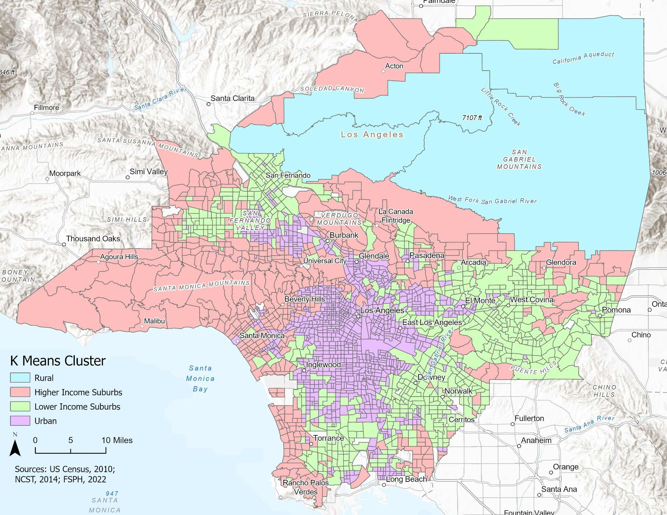
Figure 4. Map of miles biked and walked per capita in four cluster areas, Los Angeles County
Discussion
Our spatial regression results matched with what we expected. In Model 1, active transport use is significantly associated with PM2.5 concentration since walking and biking requires individuals to be outdoors and near vehicle roadways. Model 2 (stratifying for neighborhood types) showed that active transport use was not significant for PM2.5 but neighborhood types such as urban and rural were significant. This suggests that census tracts may be unequally affected by PM2.5 concentrations when accounting for neighborhood type and density. The negative correlation between median household income and PM2.5 concentrations could be due to higher income individuals living farther from pollution sources.
Our K-means cluster analysis results also showed that higher use of active transport in neighborhood clusters was associated with higher PM2.5 concentrations. Urban areas had the lowest average median income of all groups and the highest miles biked and walked per capita. Census tracts in the urban category also had the highest nonwhite and renter populations. While race/ethnicity was not a significant variable for PM2.5 in our analysis, Pratt et al. (2015) indicated that individuals of minority and low SES backgrounds are more likely to use active transport and have higher exposures to air pollution. Urban areas also had the highest mean PM2.5 concentrations which may be due to increased roadways and traffic pollution nearby. Although the median density was higher in low income suburbs, PM2.5 concentrations and active transport per capita were lower in these neighborhoods than in high income suburbs. Lastly, rural areas had the least active transport use and lowest mean PM2.5 concentrations. This is because rural areas have amenities that are spread further apart which thus requires transportation such as cars to travel (Pucher et al., 2004).
Limitations
Our study consisted of secondary data analysis which limited the data sources we could use to match variables we wished to explore. The UC Davis dataset was our main dataset because it contained the most recent and complete active transport data estimates on walking and biking. UCLA PM2.5 data utilized ambient PM2.5 measurements taken from fixed-site monitoring stations which are typically located in background locations away from busy roads. This is likely an underestimation of actual and/or potential exposure as a result of active transportation. Additionally, UCLA PM2.5 data had filter samples with low density and an unequal distribution of air sensors across LA County. Therefore, the PM2.5 data may not be fully generalizable to LA County. The UCLA PM 2.5 data was also not temporally aligned with our demographic or active transportation information. The surface used also lacks complete information for some census tracts, so the mean PM2.5 may not be valid, especially for rural and outlying tracts. We did not quantify individual PM2.5 exposure, travel times, or behaviors among bicyclists and pedestrians in our study. Furthermore, we were unable to account for geographic and weather parameters in our study due to lack of available data. Our study broadly looked at PM2.5 which can come from several sources including vehicle emissions and secondary formation, thus we suggest that one area for future research could be to explore the role that vehicle miles traveled in census tracts has on the relationship between active transport and PM2.5 concentrations. Exploring this relationship might show the distribution of emissions across neighborhoods and which populations bear the burden of these.
Implications and Policy Recommendations
Prior research has concluded that the long-term physical health benefits of active transportation outweighed the potential risks of PM2.5 exposure during use of active transport (Tainio et al., 2016). Active transport can reduce personal vehicle use and reduce polluting emission sources. Short-term exposure to PM2.5 can worsen pre-existing respiratory issues leading to increased hospitalizations and morbidity. Long-term exposure to PM2.5 has been associated with premature death, especially for those who have chronic lung and/or heart diseases and stunted lung growth in children (California Air Resources Board, 2022). Thus, while there may be some associated health tradeoffs between active transport use and PM2.5 exposure, the focus should be on building densified neighborhoods which encourage active transportation use, and can ultimately help reduce overall PM2.5 emissions.
Our results suggest that the health benefits of active transportation need to be more equitably distributed. Implementing pollutant barriers between vehicle roads and pathways designated for biking and walking can help mitigate air pollution. This can be complemented by green buffers that include native plant ecosystems, trees with large leaves, and earth mounds that could increase pollution uptake (Community Conservation Solutions, 2020). This could decrease air pollution and improve air quality for those using active transport. Policies should be aimed at addressing health inequities that arise from higher active transport use from individuals of minority and low SES. A large portion of LA County is listed in the 2022 Senate Bill 535 disadvantaged communities census tract map (CalEPA, 2022), which prioritizes funding from the Cap and Trade program to the top 25% polluted areas in California. There is potential for using these funds to improve air quality in urban areas.
Conclusion
Active transportation is beneficial to both human health and the environment through reducing the use of motorized forms of transit and thereby reducing PM2.5 emissions. The benefits of active transit however may not be equally distributed as people engaged in walking or biking may have a higher intake of air pollution. Our hypothesis that census tracts with higher use of active transport are potentially exposed to higher concentrations of PM2.5 was supported by our statistical analysis. Our results determined that income and population density were significant variables in the association between PM2.5 concentrations and census tracts with higher rates of active transport. This suggests that individuals who engage in active transportation more are also more likely to be lower income and living in densely populated areas. Our results imply that significant efforts need to be made to improve air quality so that the benefits of biking and walking are not compromised by air pollution. Doing so would protect public health and advance the equitable distribution of benefits from active transportation.
References
Cepeda, M., Schoufour, J., Freak-Poli, R., Koolhaas, C. M., Dhana, K., Bramer, W. M., & Franco, O. H. (2017). Levels of ambient air pollution according to mode of transport: A systematic review. The Lancet Public Health, 2(1), e23–e34. https://doi.org/10.1016/S2468-2667(16)30021-4
Inhalable Particulate Matter and Health (PM2.5 and PM10) | California Air Resources Board. (n.d.). Retrieved June 5, 2022, from https://ww2.arb.ca.gov/resources/inhalable-particulate-matter-and-health
Pratt, G. C., Vadali, M. L., Kvale, D. L., & Ellickson, K. M. (2015). Traffic, Air Pollution, Minority and Socio-Economic Status: Addressing Inequities in Exposure and Risk. International Journal of Environmental Research and Public Health, 12(5), 5355–5372. https://doi.org/10.3390/ijerph120505355
Salon, D., & Handy, S. (2014). Estimating Total Miles Walked and Biked by Census Tract in California: Non-Motorized Travel: Analysis of the 2009 NHTS California Travel Survey Add-On Data (No. CA14-2200). Article CA14-2200. https://trid.trb.org/view/1311855
Tainio, M., de Nazelle, A. J., Götschi, T., Kahlmeier, S., Rojas-Rueda, D., Nieuwenhuijsen, M. J., de Sá, T. H., Kelly, P., & Woodcock, J. (2016). Can air pollution negate the health benefits of cycling and walking? Preventive Medicine, 87, 233–236. https://doi.org/10.1016/j.ypmed.2016.02.002
United States Census Bureau, U. C. (n.d.-a). Beyond the Farm: Rural Industry Workers in America. The United States Census Bureau. Retrieved June 5, 2022, from https://www.census.gov/newsroom/blogs/random-samplings/2016/12/beyond_the_farm_rur.html
United States Census Bureau, U. C. (n.d.-b). Data. Census.Gov. Retrieved June 5, 2022, from https://www.census.gov/data
United States Census Bureau, U. C. (n.d.-c). Urban Areas Facts. Census.Gov. Retrieved June 5, 2022, from https://www.census.gov/programs-surveys/geography/guidance/geo-areas/urban-rural/ua-facts.html

Supplementary Figures and Table
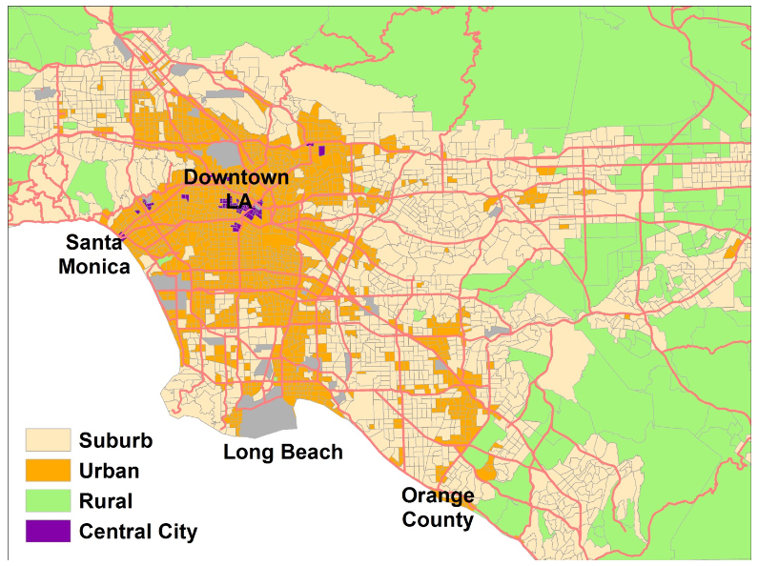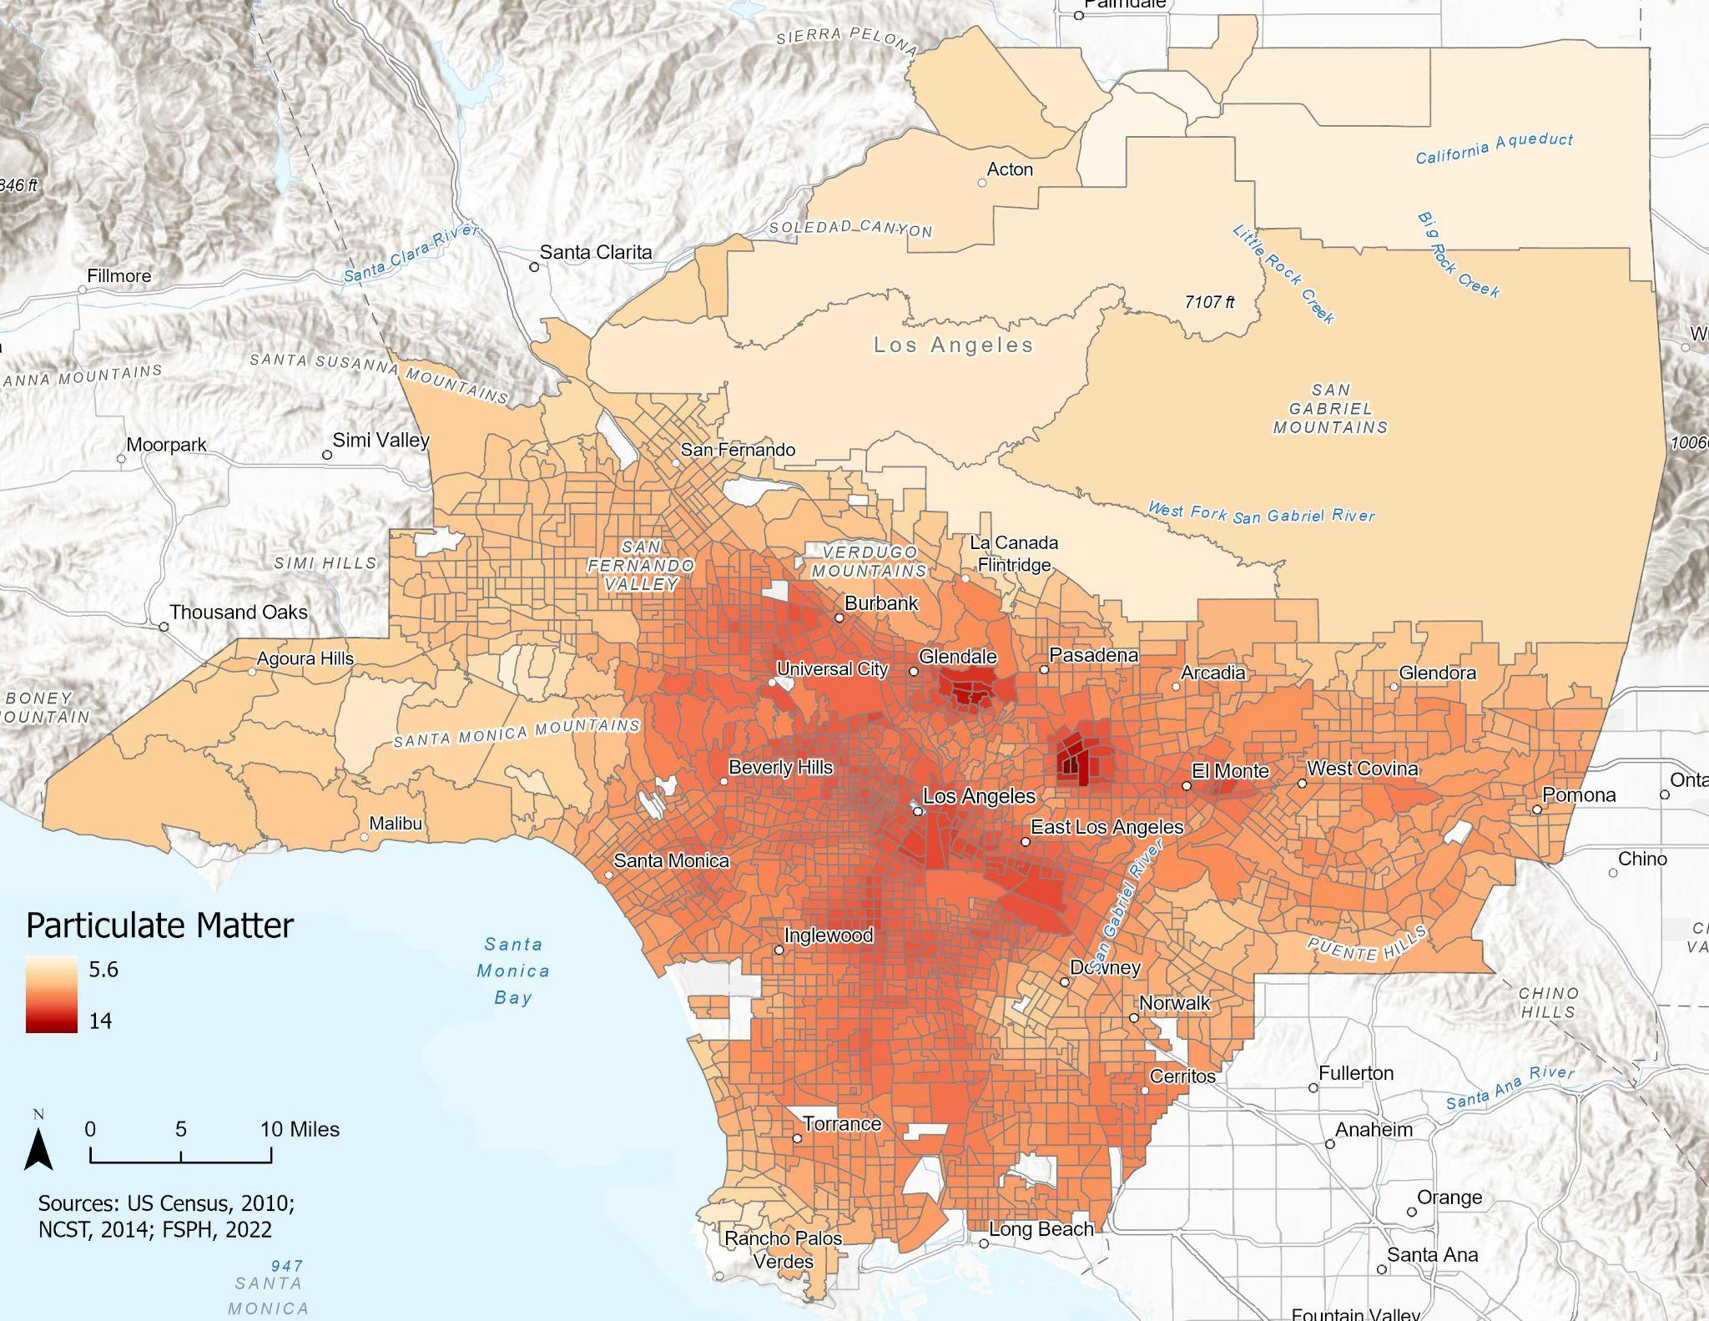
Figure S1: Neighborhood type map of the Greater Los Angeles region (Salon and Handy, 2014)
Figure S2: Average PM2.5 concentrations per census tract in Los Angeles County in 2019

Variable | Census Table
Population (Race) Estimate | P003001
Race: White, Non-Hispanic Alone | P005003
Race: Black, Non-Hispanic Alone | P005004
Race: American Indian/Alaska Native, Non-Hispanic Alone | P005005
Race: Asian, Non-Hispanic Alone | P005006
Race: Pacific Islander, Non-Hispanic Alone | P005007
Race: Some other race, Non-Hispanic | P005008
Race: Two or more, Non-Hispanic | P005009
Ethnicity: Total Hispanic/Latino of any race | P005010
Households by Tenure: Total | H004001
Households by Tenure: Renters | H004004
Table S1: Demographic variables used for this study and the corresponding Census data (US Census Bureau, 2011).

